Date18/01/2024 **G.C.**

**Application** **Letter**

Full Name**:** **Abdisa Simie Alemu**

Email Address**:** [ofgodhead@gmail.com](mailto:ofgodhead@gmail.com)

Contact**:** +**251939836645**/+251910546703

Location**:** Addis Ababa**,** Ethiopia

To: **Hiring Company**

**Position**: Applying for the Post of **Company’s Vacancy**

Dear **Hiring Company**

I have already graduated from Wollo University in the Department of Electrical and Computer Engineering on Sep 25, 2023 G.C with a 3.21 CGPA and Exit Exam result of 69%. I am highly interested in applying for your vacancy of a **Company’s Vacancy** in your organization in my field of Electrical and Computer Engineering (**Computer Engineering Specialization**) to fully serve and accomplish all duties required by the organization with the professional knowledge and practical skills that I have gained from Wollo University for 5 years. With this, I am dead sure that I can interestingly fit with the work of a **Company’s Vacancy** I believe that my academic training and my five years of experience learning as an electrical and computer engineer prepared me to be effective in tackling any challenges I will be facing.

I would enjoy discussing this position with you at any time. I have the pleasure of informing you that **it has been my long vision and great interest** to work in your organization as a **Company’s Vacancy**. Taking into consideration all this information if you give me a chance, I am ready to perform the responsibility given by your organization as far as my potential allows and to the best of my knowledge for the satisfaction of the requirement of your organization to give me the opportunity of employment. In the meantime, I am enclosing my curriculum vitae and statement of working and research interests. I would like to thank you from the bottom of my heart for your consideration.

**Huge** **Thanks** for considering me

With best regards **Abdisa Simie Alemu**

**Curriculum** **Vitae**

**1. Personal** **Details**

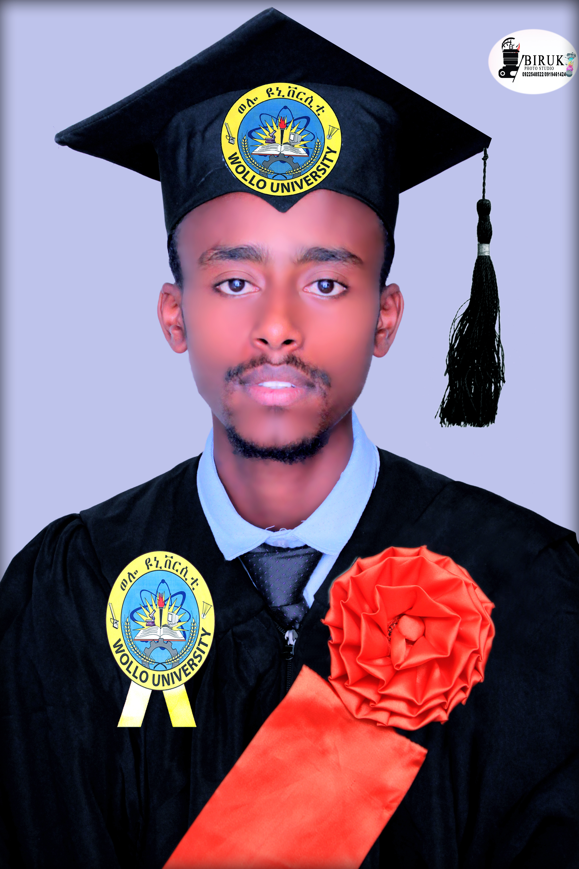 Full name**:** Abdisa Simie Alemu

Date of birth**:** 9/10/1991 EC

Place of birth**:** Sululta

Marital Status**:** Single

Nationality**:** Ethiopian

Gender**:** Male

Physical Condition**:** Normal

+Mobile**:** 251939836645/0910546703 

Location**:** Addis Ababa, Ethiopia 

Email**:** ofgodhead@gmail.com 

Academic status …………BSc. Degree in Electrical and

Computer Engineering (Computer Engineering) from Wollo University.

**2. Educational Qualification**

I accomplished a Bachelor of Science and Technology degree in Electrical and Computer Engineering specializing in Computer Engineering from Wollo University Kombolcha Institute of Technology (KIoT) at the College of Engineering on September 25 2023 G.C with a total CGPA of **3.21** and Exit Exam result of **69%.**

**3. Certifications**

I have completed and certiﬁed on different online courses like:

* HTML,
* CSS,
* PHP,
* Coding for marketers,
* jQuery, JavaScript,
* Responsive Web Design,
* Web Development Fundamentals and C# from solo learn community learning company found in California, USA.

**Additionally**, I owned Dereja/Employability Skill and Job Readiness Training with Dudayeh Wollo club certificate of recognition plus some recommendation letters in hand.

**4. Educational Background**

University**:** Wollo, Kombolcha Institute of Technology University, Nov. 2018 -April. 2023 G.C

Preparatory School**:** Addis Ababa, Medhanealem School, Sep. 2016 -Jun. 2017 G.C

High School**:** Addis Ababa, Dil Ber School, Sep. 2014 -Jun. 2015 G.C

Primary School**:** Addis Ababa, Hamle School, Sep. 2005 -Jun. 2013 G.C

**5. My** **Career** **Objective**

* I am a highly driven recent Wollo University Technology Institute graduate seeking a full-time position in electrical and computer engineering (computer engineering specialization) where I can lend my knowledge of electrical and computer engineering to help your organization improve proﬁtability.

**6.** **Project** **(Professional** **Experience)**

I have been working for 4 months at Space Science and Geospatial Institute (SSGI) in 6 Kilo, Addis Ababa during my Internship stay from February 2023 - to May 2023 based on Website development with the collaboration of database administration staff and gained meaningful sort of bits of knowledge and Web development skills and fundamentals. Additionally, I interestingly accomplished my final year thesis project entitled Pharmacy Management System with an excellent grade.

**7. My Language Skills**

|  |  |  |  |  |
| --- | --- | --- | --- | --- |
| **Language** | **Listening** | **Speaking** | **Reading** | **Writing** |
| **English** | Excellent | Excellent | Excellent | Excellent |
| **Amharic** | Excellent | Excellent | Excellent | Excellent |
| **Affan Oromo** | Excellent | Excellent | Excellent | Excellent |
| **Geez** | Passable | Passable | Excellent | Passable |

**8.** **Computer Skills**

I have been coming through various Computer Skills and fundamentals on my way to formal and informal learning like Formal learning gains and knowledge on MS Ofﬁce, C++, Java, and C#. Informal learning gains and knowledge in HTML, CSS, PHP, Coding for marketers, jQuery, Responsive Web Design, Web Development Fundamentals, JavaScript, and C#.

**9. My Hobbies and Interests**

* Knowing about Ethiopian culture and nationality.
* Hard work, citizenship, and honesty.
* Doing at least 3 creations in my profession that are highly valuable to my country.
* Struggling to advance my country's development in my profession.
* Research and scientific analysis on the problem concerning my profession.
* Visit different spritual places.
* Carry out the responsibility on which I am assigned in a good manner.

**10. My Personalities**

* Have Good relations with everyone, free from any addiction, nice Leadership skills.
* Healthily and capable of doing any type of work, disciplined and
* Positive thinker, Problem solver, confident.

**11.** **About Me**

* An enthusiastic fresher with highly motivated and leadership skills having a bachelor of engineering degree in Electrical and Computer Engineering (Computer Engineering).
* Expert in the implementation of each step of a project.
* Eager to learn new technologies and methodologies.

**12.** **Reference to Contact**

**Full Name**: Melaku Mulu

**Position**: Lecturer at Wollo University

**Email**: melakuabebe90@gmail.com

**Contact Number**: +251945414240

